Chapter 4

Building Data Models with Azure Synapse

Introduction

Azure Synapse Analytics stands as Microsoft’s unified analytics platform, seamlessly integrating big data and data warehousing. Designed to facilitate end-to-end analytics solutions, Azure Synapse enables organizations to ingest, prepare, manage, and serve data for immediate business intelligence and machine learning requirements. Its architecture merges capabilities of enterprise data warehousing, big data analytics, and data integration into a single cloud-native service.

In today’s data-driven landscape, organisations are seeking robust solutions to manage, analyse, and glean insights from massive volumes of data. Microsoft Azure Synapse Analytics, commonly known as Azure Synapse, emerges as a powerful tool for both building and managing data models at scale. In this chapter, we’ll take a closer look at how Azure Synapse helps in constructing data models, explore some practical use cases, and understand its value in the broader context of Azure Data Engineering solutions.

Azure Synapse Analytics is Microsoft’s unified cloud analytics platform that seamlessly combines enterprise data warehousing with big data analytics. It enables organizations to ingest, prepare, manage, and serve data for immediate business intelligence and machine learning needs, all from a single integrated service. In other words, Synapse brings together multiple technologies—SQL data warehousing, Apache Spark analytics, data integration pipelines, and a unified management studio—under one roof. This unified experience allows data engineers, data scientists, and analysts to collaborate in one workspace (Synapse Studio) instead of stitching together separate tools.

Synapse provides two primary analytics engines: a SQL engine (with both dedicated and serverless SQL pools for structured queries) and an Apache Spark engine for big data processing. It also includes Synapse Pipelines (built on Azure Data Factory) for ETL/ELT workflows, deep integration with Azure Data Lake Storage for scalable data storage, and out-of-the-box connectivity to Power BI and Azure Machine Learning. With Synapse, you can query both relational and non-relational data at petabyte scale, using SQL for data warehousing or Spark for data science, without needing to move data between disparate systems. The platform’s flexibility in offering on-demand (serverless) querying as well as provisioned resources means you pay for what you use, yet can achieve predictable high performance when needed.

Looking into Azure Synapse Service

Azure Synapse is an integrated analytics service that brings together big data and data warehousing. It enables seamless movement between data ingestion, preparation, management, and serving for business intelligence and machine learning purposes. With Synapse, you can query both relational and non-relational data at scale using either serverless or provisioned resources, making it extremely flexible for different business scenarios.

At its core, Synapse is composed of several crucial components: Synapse SQL pools, Apache Spark pools, Synapse Pipelines for orchestration, integrated Data Lake Storage, and a rich studio experience that brings together management, development, and monitoring tools under one pane of glass.

For academic learners and Azure architects, understanding the foundational elements of Synapse is essential. It allows organizations to harness data from disparate sources, apply robust transformations, and deliver analytics at scale—all with the security, governance, and compliance of the Azure ecosystem.

Key components of Azure Synapse include:

* **Synapse SQL Pools** – MPP (Massively Parallel Processing) SQL engines for querying data. You can use Dedicated SQL Pools, which are provisioned resources optimized for high-performance warehousing (with compute scaled in Data Warehouse Units), or Serverless SQL Pools, which let you run T-SQL queries on data in storage without provisioning compute (you pay per TB of data scanned). This combination offers flexibility: for regular heavy workloads, a dedicated pool provides predictable performance, while serverless is great for adhoc queries on your data lake.
* **Apache Spark Pools** – Integrated Spark clusters for big data processing and machine learning. They allow you to use PySpark, Scala, SQL, or .NET to process data at scale in-memory, ideal for complex transformations or ML tasks that go beyond SQL.
* **Synapse Pipelines** – Built-in data integration pipelines (akin to Azure Data Factory) for orchestrating data movement and transformation. Over 100 connectors are available to ingest data from various sources into Synapse, and you can design ETL flows with a drag-and-drop interface or code, including support for Mapping Data Flows (visual data transformations running on Spark).
* **Azure Data Lake Storage Gen2 integration** – Every Synapse workspace is typically linked with an ADLS Gen2 account which serves as the data lake. This is where raw data lands and intermediate data can be stored. Synapse can query data directly from the lake (especially using serverless SQL or Spark) and also load it into structured tables for fast querying.
* **Synapse Studio** – A unified web UI where you can manage all the above. It provides dedicated hubs: Data (to browse databases and files), Develop (to work on SQL scripts, notebooks, and code), Integrate (pipelines), and Monitor (to track jobs and performance). This single pane of glass greatly simplifies collaboration and development workflows.

## Data modelling with Azure Synapse

Constructing a data model is at the heart of any analytics solution. Within Azure Synapse, you can design, implement, and manage sophisticated data models that cater to your organisation’s analytical needs. Azure Synapse offers a spectrum of tools to handle data from ingestion to insight within one system. You can bring in data from multiple sources, shape it into an analytics-friendly schema, and then use that model to serve insights through BI or AI – all with built-in security and governance of the Azure ecosystem. The tight integration with tools like Power BI means once your data model (e.g. star schema) is in place in Synapse, creating live dashboards or embedding the results into applications is straightforward. Let’s break down how this process typically unfolds:

**Data Ingestion**: Azure Synapse makes it easy to bring in data from a variety of sources—think SQL databases, cloud storage, SaaS applications, and even real-time streams. Using Synapse Pipelines (powered by Azure Data Factory), you can automate data ingestion, ensuring your model always has up-to-date information.

An example reference architecture depicting how to use Azure Synapse for Data model development using real-time data streaming.

Figure 1: Reference architecture of Azure Synapse Analytics

**Data Transformation**: Once the data lands in Synapse, you can use SQL, Apache Spark, or Data Flows to clean, transform, and enrich your raw data. This step is crucial because it shapes the data into the desired format for analytical modelling.

**Data Modelling**: With integrated support for SQL-based data warehousing, you can define tables, relationships, and business logic directly within Synapse. Whether you prefer dimensional (star, snowflake) or relational models, Synapse offers the flexibility to design what suits your analytical needs best.

**Data Serving and Consumption**: Once your model is ready, it can power dashboards, reports, and machine learning models. Synapse integrates with Power BI, making it straightforward to visualise your data and share insights across the organisation.

Key Features of Synapse Analytics are:

* On-demand and provisioned query processing
* Tightly integrated Apache Spark and SQL analytics engines
* Built-in data integration and orchestration (Synapse Pipelines)
* Deep integration with Azure Data Lake Storage Gen2
* Comprehensive data security, monitoring, and governance

Example:

Imagine a retail company that collects data from point-of-sale systems, inventory databases, online web logs, and customer feedback. Azure Synapse can bring together these disparate data sources, transform raw data, and deliver actionable insights to business users, analysts, and machine learning models.

## Practical Use Cases for Synapse Solutions

Azure Synapse isn’t just a theoretical solution—it shines in real-world applications. Here are some practical scenarios where Synapse adds immense value:

* **Customer Analytics**: Retailers can unify data from online, in-store, and third-party sources to build comprehensive customer profiles. With Synapse, it’s possible to model customer journeys, segment audiences, and predict buying behaviour, all in one place.
* **IoT Data Insights**: Manufacturers dealing with thousands of IoT sensors can ingest, process, and analyse real-time data streams. Synapse helps model this data efficiently, enabling predictive maintenance and process optimisation.
* **Fraud Detection**: Financial institutions can bring together transactional and behavioural data, model patterns, and detect anomalies in near real-time. Synapse’s scalability means it can handle millions of records without breaking a sweat.
* **Healthcare Data Integration**: Hospitals and research centres can aggregate patient data, lab results, and imaging data to build models that support better diagnosis, treatment recommendations, and operational insights.
* **Supply Chain Optimisation**: Organisations can model supply chain activities by integrating data from vendors, logistics partners, and sales. Synapse helps uncover bottlenecks, reduce costs, and improve delivery timelines.

## Synapse for Azure Data Engineering Solutions

Data engineering is all about building reliable, scalable, and maintainable data pipelines and structures. Azure Synapse stands out as a cornerstone for these solutions, offering several advantages:

1. **Unified Platform**: Synapse combines data integration, warehousing, and big data analytics in a single environment. This reduces the need to stitch together multiple tools, making life easier for data engineers.
2. **Scalability**: Whether you’re dealing with gigabytes or petabytes, Synapse scales up or down as needed. This flexibility ensures your data models remain performant as your organisation grows.
3. **Security and Compliance**: Built-in features like data masking, encryption, and access control help meet regulatory requirements—something especially important for sensitive industries like finance and healthcare.
4. **Cost Efficiency**: With serverless options, you only pay for what you use, making it cost-effective for both small and large teams.
5. **Integration with the Azure Ecosystem**: Synapse works seamlessly with services like Azure Machine Learning, Power BI, and Azure Data Lake, enabling end-to-end solutions from data ingestion to advanced analytics and reporting.

Building data models with Azure Synapse offers organisations a comprehensive, scalable, and flexible platform for unlocking actionable insights from their data. Its real-world use cases span industries, from retail and finance to healthcare and manufacturing, making it a robust choice for any data-driven initiative. By streamlining data engineering workflows and integrating tightly with the broader Azure ecosystem, Synapse empowers teams to focus more on innovation and less on infrastructure management, paving the way for smarter decisions and better business outcomes.

## Recipe: Setting Up Your Azure Synapse Environment

Embarking on a journey with Azure Synapse Analytics means stepping into a world where data integration, big data, and advanced analytics come together seamlessly. Setting up your Azure Synapse environment is the foundational recipe for unlocking the full potential of data-driven insights.

## Azure Services Required for the Recipe

To build an effective Synapse environment, you need to leverage several key Azure services. Here’s a brief overview of the main ingredients:

* **Azure Synapse Workspace**: The central hub where all your data activities take place.
* **Azure Data Lake Storage Gen2**: Provides scalable and secure cloud storage for your data files.
* **Azure Active Directory (AAD)**: Manages user access and authentication, ensuring secure workspace operations.
* **Azure Key Vault**: Safeguards secrets, keys, and credentials used within your Synapse environment.
* **Azure SQL Database or Dedicated SQL Pools**: Supports data warehousing and structured query operations.
* **Azure Monitor and Log Analytics**: Offers monitoring and logging capabilities to keep track of usage, performance, and security.

## Step-by-Step Guide to Setting Up Your Synapse Environment

### Step 1: Provision a Synapse Workspace

Begin by signing into your Azure portal. Search for ‘Azure Synapse Analytics’ and select ‘Create a workspace’. You’ll be prompted to specify basic details like subscription, resource group, workspace name, and region. It’s best to choose a resource group that aligns with your project for easier management.

### Step 2: Configure Data Storage

Every Synapse workspace needs a data lake for storing large datasets. During workspace setup, link your workspace to an existing Azure Data Lake Storage Gen2 account or create a new one. This storage will serve as the primary landing zone for raw, curated, and transformed data.

### Step 3: Set Up Network and Security

Network security is paramount. You can choose to deploy Synapse within a virtual network to restrict access and enhance security. Azure Active Directory comes into play here, managing who can access the workspace and what permissions they have. For sensitive information, integrate Azure Key Vault to store connection strings, passwords, and other secrets securely.

### Step 4: Create SQL Pools and Spark Pools

Depending on your analytics needs, you may want to set up dedicated SQL pools for high-performance data warehousing or Spark pools for big data processing. This step involves choosing the number of nodes, configuring performance levels, and linking them to your data sources.

### Step 5: Connect to Data Sources

With your workspace and pools ready, it’s time to connect to various data sources. Azure Synapse supports connections to databases, external storage accounts, and even on-premises systems. You can use built-in connectors or configure integration runtimes for more advanced scenarios.

### Step 6: Monitor and Manage

Once everything is up and running, use Azure Monitor and Log Analytics to keep tabs on activity, performance, and security. Setting up alerts, dashboards, and logs ensures that you’re always aware of what’s happening in your Synapse environment.

## Developing the Recipe: Bringing It All Together

Developing the Azure Synapse environment recipe involves orchestrating the above services and steps in a logical, secure, and scalable manner. First, you plan the architecture—deciding which data sources, storage accounts, and analytics pools you need. Then, you provision resources in Azure, carefully configuring security and access control to protect sensitive data. After connecting your data sources and setting up analytics engines, you establish monitoring to ensure the environment runs smoothly over time.

Throughout this process, collaboration is key. Azure Synapse supports multiple users with role-based access, allowing data engineers, analysts, and business users to work together within the same workspace. As your needs grow, you can expand storage, scale compute resources, and integrate additional Azure services like Power BI for advanced visualisation.

Setting up your Azure Synapse environment is the essential first step for any data analytics project on Azure. By thoughtfully combining storage, compute, security, and monitoring services, you create a foundation that supports scalable, secure, and collaborative analytics. With this recipe in hand, your organisation is well-equipped to harness the full power of data and deliver actionable insights.

Step-by-Step Recipe:

* Log into the Azure portal and provision a Synapse workspace.
* Configure Synapse SQL and Spark pools as required.

Figure: Linked Service in creating Azure synapse

* Establish connections to data sources and storage accounts.

Figure: Linked Service created in setting up Azure Synapse service

* Use Synapse Studio for development and management workflows.

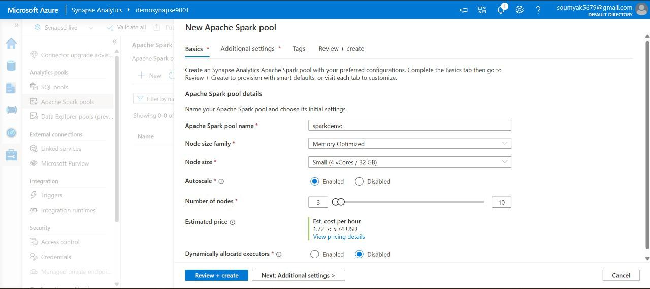

Figure: Final step in Azure Synapse Environment setup

Designing Data Schemas

Schema design is a cornerstone of effective data modelling. In Azure Synapse, schema design not only impacts performance but also underpins maintainability, scalability, and security. Synapse supports both structured and semi-structured data, allowing architects to model star, snowflake, or even data vault schemas depending on organizational needs.

**Star Schema**: In this classic warehouse model, a central fact table encapsulates measurable events (such as sales transactions), while surrounding dimension tables describe entities like time, customer, or product. The schema’s simplicity enables performant analytic queries.

**Snowflake Schema**: Expands on the star schema by normalizing dimensions into multiple related tables. While more complex, this can improve data integrity and reduce storage costs at the expense of slightly more complex queries.

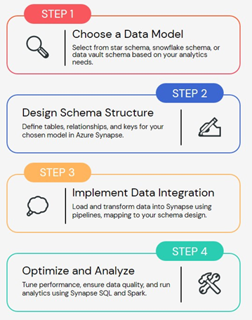

Figure 2: Data modelling with Azure Synapse

**Schemas in Synapse**: In Synapse SQL, schemas are namespace containers that help organize objects (tables, views, procedures) and manage access control. Proper schema planning is essential for large-scale analytics environments.

## Example: Designing a Retail Data Model

Suppose you’re tasked with building a data warehouse for a retail chain. Begin by identifying the fact tables (e.g., Sales, InventoryMovements) and dimensions (Products, Stores, Dates, Customers). Apply normalization and denormalization judiciously, balancing query performance and storage efficiency.

*Sample Table Definitions:*

*-- Dimension: Products*

*CREATE TABLE dbo.DimProducts (*

*ProductKey INT PRIMARY KEY,*

*ProductName NVARCHAR(100),*

*Category NVARCHAR(50),*

*Brand NVARCHAR(50)*

*);*

*-- Fact: Sales*

*CREATE TABLE dbo.FactSales (*

*SalesKey BIGINT IDENTITY(1,1) PRIMARY KEY,*

*ProductKey INT,*

*StoreKey INT,*

*DateKey INT,*

*Quantity INT,*

*TotalAmount DECIMAL(18,2),*

*FOREIGN KEY (ProductKey) REFERENCES dbo.DimProducts(ProductKey)*

*);*

## Recipe: Ingesting Data from Multiple Sources

In today’s data-driven world, organisations often need to bring together information scattered across different systems, formats, and locations. The process of “Ingesting Data from Multiple Sources” refers to collecting, importing, and consolidating data from various origins into a central repository, typically for purposes like analytics, reporting, or further data processing. This recipe is fundamental in building robust and insightful data solutions, especially in large enterprises where data silos are common.

Businesses rarely operate with just one data source. Customer data might reside in cloud databases, sales figures in on-premises SQL servers, website logs in storage accounts, and third-party data in external APIs. To get a complete and actionable view, it’s crucial to aggregate these diverse datasets into one accessible location, ensuring that analytics and business intelligence tools have a unified view of the data landscape.

## Key Azure Services for Multi-Source Data Ingestion

Microsoft Azure provides a comprehensive suite of services designed to make data ingestion seamless, scalable, and secure. Here’s an overview of the primary Azure services you’d typically use when developing a multi-source data ingestion solution:

* **Azure Data Factory (ADF)**: This is the main orchestrator for data movement and transformation. It allows you to connect to a wide range of data sources, schedule pipelines, and automate data workflows.
* **Azure Data Lake Storage (ADLS)**: A highly scalable and secure data lake for storing both structured and unstructured data. It acts as the central repository where ingested data lands.
* **Azure Synapse Analytics**: Useful for advanced analytics, it can directly consume data from the Data Lake and perform complex queries or data transformations.
* **Azure Logic Apps**: For scenarios requiring event-driven or workflow-based triggers, Logic Apps can automate the start of data ingestion processes.
* **Azure Event Hubs or IoT Hub**: These are ideal for real-time streaming data, such as telemetry from devices or application logs.
* **Azure Blob Storage**: Another cost-effective storage solution for raw files, logs, or intermediate data dumps.
* **Azure Key Vault**: To manage and secure connection strings, API keys, and other secrets required to connect to sources securely.

## Step-by-Step: Building the Ingestion Recipe

### 1. Identifying and Connecting to Data Sources

The first step is to list out all the data sources you need to ingest from. These might include on-premises databases, cloud SQL databases, flat files (CSV, JSON, XML), SaaS platforms (like Salesforce), REST APIs, or streaming sources. Using Azure Data Factory, you can set up Linked Services for each of these sources, which essentially act as connection objects storing credentials and configuration.

### 2. Designing the Data Ingestion Pipelines

Within Azure Data Factory, you create Pipelines that define the workflow for moving data. Each pipeline can have multiple Activities, such as copying data from a source, transforming the data, and loading it into a destination. Pipelines can be scheduled to run at specific intervals or triggered based on events.

### 3. Data Movement and Transformation

For each data source, use the Copy Data activity to extract data. If the data needs to be cleaned, transformed, or enriched before storing, you can use Data Flow activities within ADF, which provide a visual, code-free interface for data transformations. These transformations might include joining multiple datasets, filtering records, or reformatting fields.

### 4. Storing Ingested Data

Once the data is moved and optionally transformed, it’s loaded into a central store like Azure Data Lake Storage or Blob Storage. This storage acts as the staging or persistent layer, making data available for further processing, analytics, or reporting.

### 5. Handling Real-Time Data

If you have streaming data sources (for example, IoT devices or application logs), use Azure Event Hubs or IoT Hub to capture real-time streams. These services integrate with Azure Stream Analytics or Data Factory, allowing you to process and route streaming data to your storage or analytics layers.

### 6. Automating and Securing the Process

Automation can be achieved using ADF triggers or Logic Apps, ensuring that data ingestion runs on schedule or in response to specific events, like file arrival or API updates. To maintain security, all connection secrets and credentials are stored in Azure Key Vault, and permissions are managed via Azure Active Directory.

## Example Workflow: Putting It All Together

Let’s say a company wants to ingest customer data from an on-premises SQL Server, sales data from a cloud-based MySQL database, and product information from a REST API. Here’s how the process would look:

1. Set up Linked Services in Azure Data Factory for SQL Server, MySQL, and the REST API.
2. Create Pipelines that extract data from each source using Copy Data activities.
3. Transform the data as required (for example, mapping column names, cleansing records) using Data Flows.
4. Load all ingested and transformed data into Azure Data Lake Storage.
5. Schedule pipelines to run daily, or set up triggers to run them whenever new data is available.
6. Secure all secrets and connection details in Azure Key Vault.

Please note some tips to build the recipe based on best practices implementation as below:

* **Monitor Pipelines**: Use ADF monitoring tools to track pipeline executions and quickly respond to failures.
* **Optimise Data Movement**: Where possible, use parallelism and partitioning to speed up ingestion.
* **Maintain Data Quality**: Incorporate data validation and cleansing steps within your pipelines.
* **Document Pipelines**: Keep your pipeline logic well documented for future maintenance and audits.

Ingesting data from multiple sources is a critical capability for modern enterprises aiming to leverage their diverse data assets. Azure’s ecosystem offers flexible, scalable, and secure tools to streamline this process, ensuring your data is always ready for analysis and decision-making. By following the recipe outlined above, you can build a robust ingestion solution tailored to your organisation’s unique data landscape.

Azure Synapse Pipelines facilitate ingesting data from SQL, Blob, ADLS, Cosmos DB, and more.

Example:

*-- Ingest data from Azure Blob Storage*

*COPY INTO dbo.StagingSales*

*FROM '[URL]'*

*WITH (*

*FILE_TYPE = 'CSV',*

*CREDENTIAL = (IDENTITY= 'Managed Identity')*

*)*

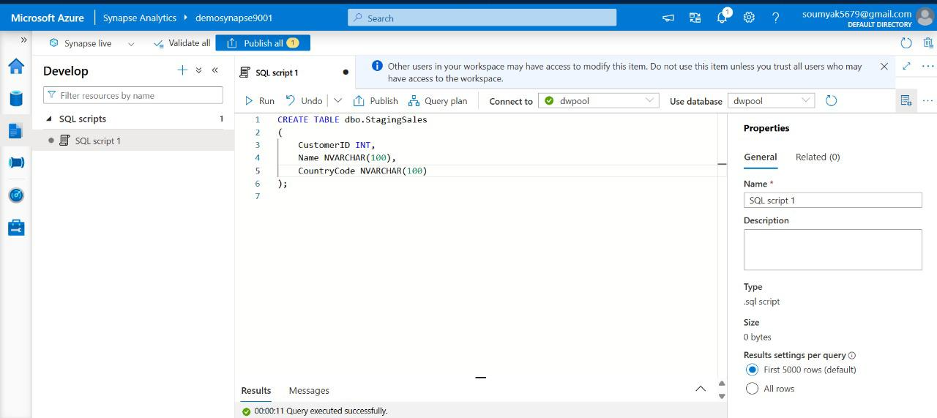

Figure: Screenshot showing Staging table creation for Data ingestion

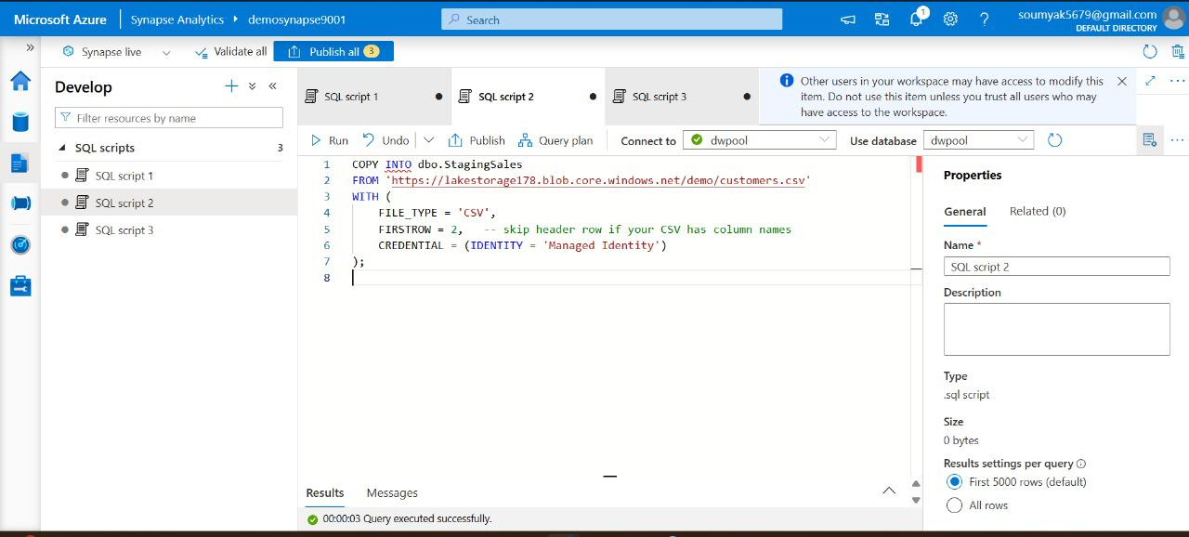

Figure: Screenshot showing Data ingestion into Staging table from Lake storage feed

Some of the best Practices in data modelling with Azure Synapse are as follows:

* Choose surrogate keys for dimensions to optimize join performance.
* Use schemas to segment objects by functional area (e.g., staging, core, analytics).
* Document data lineage and relationships for maintainability and governance.

Creating Tables and Views

Table and view creation forms the backbone of data storage and logical representation in Synapse. Tables hold persistent data, while views provide dynamic, often aggregated, windows into the stored data, allowing for abstraction and simplified querying.

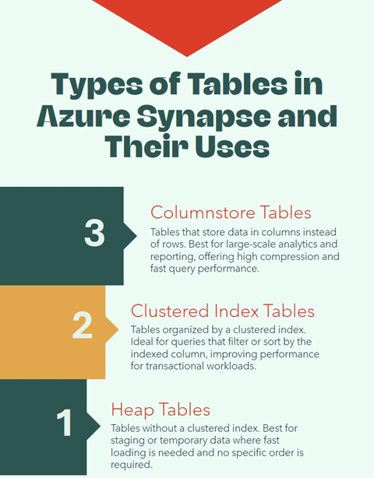

Figure: Infographic showing Azure synapse table types and its uses

**Types of Tables:**

* **Heap Tables**: No clustered index, suitable for fast inserts in staging scenarios.
* **Clustered Index Tables**: Organize data on disk for efficient retrieval.
* **Columnstore Tables**: Store data in columns and provide high compression, ideal for analytic workloads.

*Example: Creating a Fact and Dimension Table*

*-- Clustered columnstore for Fact Table (fast analytics)*

*CREATE TABLE dbo.FactSales*

*(*

*SalesKey BIGINT IDENTITY(1,1) PRIMARY KEY,*

*ProductKey INT,*

*StoreKey INT,*

*DateKey INT,*

*Quantity INT,*

*TotalAmount DECIMAL(18,2)*

*)*

*WITH (CLUSTERED COLUMNSTORE INDEX);*

*-- Heap for staging table*

*CREATE TABLE staging.StagingSales*

*(*

*...*

*)*

*WITH (HEAP);*

## Creating Views

Views are used to present complex data relationships in a simple way. For instance, a view that combines sales and product details can aid analysts. A view in Synapse is a saved SQL query that presents data from one or more tables. Views can be very useful in a data model for a few reasons:

* **Simplifying complex logic**: If analysts frequently need to join several tables or apply filters, you can encapsulate that in a view. For example, a view that joins FactSales with DimProduct and DimDate might present a flatter “sales with product and date info” to the user, so they don’t have to write the joins each time.
* **Security and access control**: You can restrict users’ access to base tables and give them access to certain views only. For instance, a view might filter out sensitive data or mask certain columns. Synapse supports row-level security via security policies in dedicated SQL pools, but even without that, a view can serve a similar purpose by pre-filtering rows (though not as secure as true RLS). Also, dynamic data masking works on underlying columns, but a view can select non-masked expressions if you want to expose them differently.
* **Abstraction**: If you ever change the underlying table structure, you can keep the view interface the same so that users or tools are not affected. For example, if you partitioned a table or switched to a new Fact table, you could create a view with the old name for backward compatibility.

Creating a view is straightforward. Here’s an example view that an analyst might use to get a quick sales summary by product:

*1 CREATE VIEW analytics.vw_ProductSalesSummary AS*

*2 SELECT*

*3 p.Category,*

*4 p.ProductName,*

*5 d.Year,*

*6 SUM(f.TotalAmount) AS TotalSales,*

*7 SUM(f.Quantity) AS UnitsSold*

*8 FROM dbo.FactSales AS f*

*9 JOIN dbo.DimProduct AS p*

*10 ON f.ProductKey = p.ProductKey*

*11 JOIN dbo.DimDate AS d*

*12 ON f.DateKey = d.DateID*

*13 GROUP BY p.Category, p.ProductName, d.Year;*

This view joins the sales fact with product and date dimensions, and aggregates total sales and units sold by product (name, category) and year. Now an analyst can simply SELECT * FROM analytics.vw_ProductSalesSummary WHERE Year = 2025 AND Category = 'Electronics'; to get results, without knowing the underlying schema detail.

## Recipe: Transforming Data with Data Flow

Imagine you're tasked with building a robust data pipeline that ingests, transforms, and stores data from multiple sources—say, an on-prem SQL Server and Azure Blob Storage. The goal is to make this data usable for analytics, reporting, or machine learning. This recipe walks you through how to do just that using Azure’s powerful ecosystem.

**Azure Services Required**

Here’s a breakdown of the key Azure services used in this recipe:

1. **Azure Data Factory (ADF)** – The backbone of the pipeline. It orchestrates data movement and transformation.
2. **Azure Data Lake Storage Gen2 (ADLS)** – Acts as the scalable storage layer for raw and processed data.
3. **Azure Monitor & Log Analytics** – Provides visibility into pipeline health, performance, and failures.
4. **Azure Logic Apps** – Automates responses to alerts and failures.
5. **Azure SQL Database or Synapse Analytics** – Optional destinations for enriched data.
6. **Power BI** – For visualizing the final output.

**Step-by-Step Development of the Recipe**

**Step 1: Set Up Azure Data Lake Storage (ADLS Gen2)**

Start by creating a storage account in the Azure Portal. Enable hierarchical namespace to activate Data Lake features. This gives you a cloud-native file system that’s perfect for big data workloads.

* Assign RBAC roles and POSIX ACLs for secure access.
* Configure encryption, firewall rules, and private endpoints for security.

**Step 2: Build the Pipeline in Azure Data Factory**

ADF is where the magic happens. You’ll use its visual interface to design a pipeline that pulls data from your sources and lands it in ADLS.

* **Linked Services**: Define connections to SQL Server and Blob Storage.
* **Datasets**: Represent the source and destination data structures.
* **Activities**: Use “Copy Data” to move data, and “Data Flow” for transformations.
* **Triggers**: Schedule the pipeline to run nightly or based on events.

Example: A retail company combines sales data from SQL Server with product info from Blob Storage, transforming and loading it into ADLS for reporting.

**Step 3: Transform Data with Mapping Data Flows**

ADF’s Mapping Data Flows let you visually design transformations using Spark clusters.

* Add transformations like Filter, Aggregate, Derived Column, and Conditional Split.
* Debug with sample data and publish once validated.

Example: Standardize phone numbers, split customers into active/inactive, and aggregate sales by region.

**Step 4: Monitor and Troubleshoot with Azure Monitor**

Once your pipeline is live, you’ll want to keep an eye on it.

* Enable diagnostics in ADF to send logs to Log Analytics.
* Use Azure Monitor to set up alerts for failed runs.
* Drill into logs to identify bottlenecks or errors.

**Step 5: Automate Responses with Logic Apps**

Don’t just monitor—respond automatically.

* Configure Logic Apps to restart failed pipelines or notify teams.
* Test automation by simulating failures.

**Step 6: Visualize with Power BI**

Connect Power BI directly to ADLS or Azure SQL to build dashboards that reflect real-time insights.

This recipe isn’t just a technical checklist—it’s a blueprint for building resilient, scalable, and secure data pipelines. By combining Azure Data Factory’s orchestration with ADLS’s storage capabilities and Azure Monitor’s observability, you create a system that’s not only powerful but also maintainable and cost-effective.

Data Flows in Synapse Pipelines enable no-code transformations with a drag-and-drop interface.

Example:

* Create a data flow that joins customer and sales data, applies filters, and writes to a curated table.

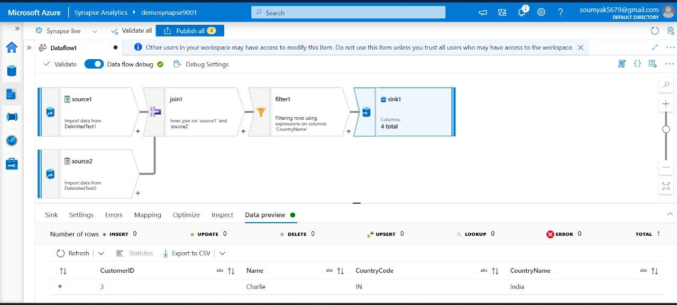

## Recipe: Designing and Building Data Models

At its core, this recipe involves creating a structured, scalable, and high-performing data model that supports analytics, reporting, and business intelligence needs. The process combines data ingestion, transformation, modelling, and serving, all orchestrated within Azure Synapse and its ecosystem.

## Key Azure Services Involved

* **Azure Synapse Analytics**: The main platform, combining enterprise data warehousing, big data analytics, and data integration.
* **Azure Data Lake Storage Gen2**: Used for storing raw and curated data at scale, serving as the foundation for data ingestion and processing.
* **Azure Data Factory**: Handles data movement, orchestration, and transformation pipelines, enabling seamless integration of data from multiple sources.
* **Azure SQL Database or Dedicated SQL Pools**: Provides a relational data store for structured data and supports complex queries and modelling.
* **Power BI**: Connects with Synapse for visualisation, reporting, and analytics, allowing end-users to interact with the data model.

## Step-by-Step Development of the Recipe

### **1. Requirement Analysis and Data Source Identification**

Begin by engaging with stakeholders to clearly understand the business requirements, analytics goals, and key performance indicators (KPIs). Identify the data sources—these could be operational databases, flat files, cloud storage, APIs, or even streaming data feeds.

### **2. Ingesting Data into Azure Synapse**

Leverage Azure Data Factory to create pipelines that pull in data from various sources into Azure Data Lake Storage Gen2. This step ensures raw data is available in a central, secure, and scalable location. Data may be ingested in batch or near real-time, depending on the use case.

### **3. Data Transformation and Cleansing**

Once the data lands in the lake, use Synapse’s Serverless SQL Pools or Spark Pools for data transformation. This could involve cleaning, standardising, removing duplicates, and enriching the data. Data engineers typically use SQL scripts or Spark notebooks for these transformations, ensuring the data is analytics-ready.

### **4. Data Modelling and Structuring**

With clean data, the next step is to design the data model. This often involves creating star or snowflake schemas in the Dedicated SQL Pools within Synapse. Define fact tables (for transactional data) and dimension tables (for descriptive attributes), ensuring optimal relationships, indexes, and partitions for performance. Normalisation and denormalisation strategies are considered, depending on query patterns and reporting needs.

### **5. Data Serving and Analytics**

After modelling, data is made accessible for analysis and reporting. Power BI can connect directly to Synapse SQL Pools or use the Synapse workspace as a data source. This enables users to build interactive dashboards and reports, driving data-driven decision-making.

### **6. Orchestration and Automation**

Automate the entire workflow using Azure Data Factory or Synapse pipelines. Schedule data refreshes, monitor pipeline health, and set up alerts for failures or anomalies. This ensures the data model stays current and reliable without manual intervention.

### **7. Security and Governance**

Implement security best practices by configuring role-based access, data masking, and encryption. Leverage Azure Purview for data cataloguing and governance, ensuring compliance with organisational and regulatory standards.

## **Best Practices for Building Data Models in Azure Synapse**

* Design for scalability, anticipating future data growth and evolving business needs.
* Optimise queries and indexing to enhance performance, especially for large datasets.
* Document data lineage and transformations for transparency and troubleshooting.
* Regularly review and update security configurations to protect sensitive data.

Designing and building data models with Azure Synapse is a collaborative and iterative journey. By leveraging Azure’s powerful suite of services, organisations can create robust, scalable, and secure data models that serve as the backbone for analytics and business intelligence. The recipe outlined above provides a structured approach, ensuring data is ingested, transformed, modelled, and served efficiently while maintaining governance and security standards.

Steps involved for this recipe as follows:

* Define fact and dimension tables as per your schema design.
* Use surrogate keys and enforce referential integrity via foreign keys.
* Implement slowly changing dimensions using additional columns and audit logs.

Example:

*-- Example code for slowly changing dimension*

*ALTER TABLE dbo.DimCustomer*

*ADD StartDate DATETIME2, EndDate DATETIME2;*

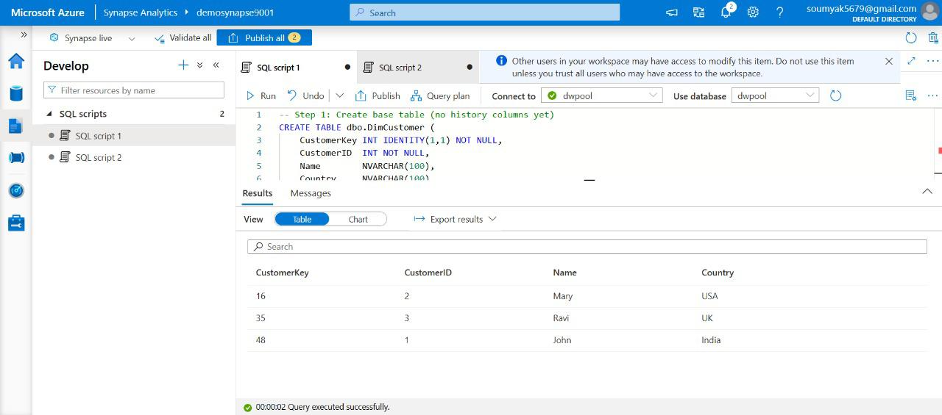

Figure: Screenshot showing table creation

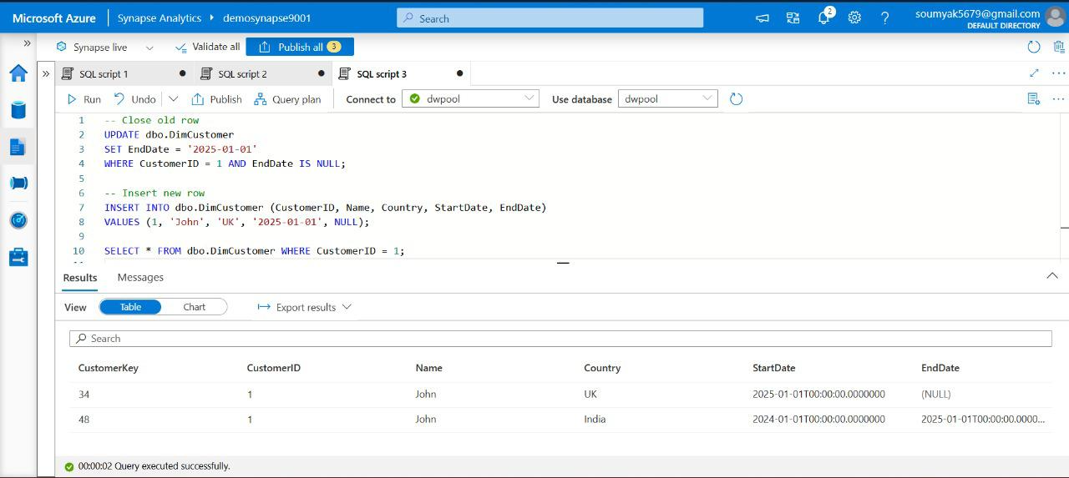

Figure: Screenshot showing changing dimensions using additional columns and Data insertion

Here are some of the best Practices or tips in creating views in Azure Synapse solutions.

* Name tables/views using consistent, descriptive conventions.
* Leverage schema separation to control access.
* Regularly review and refactor views for optimization.

Query Optimization Techniques

Efficient query execution is critical for large-scale analytics workloads. Synapse provides several mechanisms to tune and optimize query performance.

Techniques:

* **Distribution Methods**: Select between HASH, ROUND_ROBIN, REPLICATE for table distribution to optimize joins and aggregations.

In a Synapse dedicated SQL pool, tables are sharded across 60 distributions (think of them as 60 micro-databases across compute nodes). How the rows of a table are distributed is defined by the DISTRIBUTION option at create time. The choices are:

* **HASH distribution** – You specify a column, and Synapse uses a hash function on that column’s value to decide which distribution (1 to 60) each row belongs to.

*Example: DISTRIBUTION = HASH(ProductID).*

This is generally used for large **fact tables** or large dimensions. The goal is to spread data evenly and allow collocation of joins. For instance, if FactSales is hash-distributed on ProductID and DimProduct is small enough to replicate (or also hashed on ProductID, though typically you’d replicate DimProduct since it’s smaller), then a join between them requires no data movement because rows with the same ProductID all reside in the same node. Hash distribution is great for large tables especially when you frequently join or aggregate on that key. You want to pick a distribution key with high cardinality (many distinct values) so data spreads evenly and avoid a data skew (e.g., hashing on a constant or low-cardinality column would put lots of rows into a single distribution, which is bad).

* **ROUND_ROBIN distribution** – Synapse just distributes rows evenly but arbitrarily across distributions. This is the default if you don’t specify otherwise. Round-robin is simple and works fine for smaller or staging tables, but when joining a round-robin table to another, Synapse often needs to shuffle data because there’s no guarantee of collocation. It’s best for **staging** or transient tables or when a table isn’t too large and doesn’t join often.
* **REPLICATE distribution** – A full copy of the table is kept on each of the 60 distributions. This is only allowed for small tables (there’s no hard row limit, but obviously copying a huge table 60 times is impractical). Replicated tables are fantastic for **small dimension tables or reference data** used in joins, because every node has the entire table, so no shuffle needed. For example, a DimDate with a few thousand rows or a DimStore with 100 rows can be replicated.
* **Partitioning**: Use table partitioning on large tables to improve query performance and manageability. Partitioning is an additional layer of data subdivision *within* each distribution. You can partition a table on a column, often a date, so that data is segmented by that column’s value (e.g., one partition per month or year). Partitioning can improve manageability (e.g., loading/dropping one month of data is easier if the table is partitioned by month) and in some cases improve query performance via **partition elimination** (if a query filters on the partition column, it can skip scanning partitions that don’t meet the criteria).
* **Statistics and Indexing**: Maintain up-to-date statistics and appropriate indexing strategies. The query optimizer of Synapse relies on statistics to make decisions about joins and execution plans. Statistics are summary info on data distribution (like histograms on a column). In Synapse, when you create a table, it does not automatically create stats on every column. Auto-stats may kick in for columns used in predicates, but importantly stats are not auto-updated after large data loads. A common performance issue is outdated stats leading to suboptimal query plans.

Synapse also supports creating nonclustered indexes on columnstore tables (useful for selective queries) and clustered indexes (rowstore) if needed. Some dimensions that are small could be made clustered rowstore instead of columnstore if they are often accessed via single keys. However, one upside of columnstore on even moderate-size dimensions is the compression; it might still be beneficial unless the dimension is tiny.

* **Materialized Views**: Precompute and store complex aggregations for faster access.
* **Resource Classification**: Assign workloads to appropriate resource classes to ensure SLAs.

Example: Choosing Table Distribution

*-- Create a HASH distributed table*

*CREATE TABLE dbo.FactSales*

*(*

*...*

*)*

*WITH (DISTRIBUTION = HASH(ProductKey));*

*Query Tuning Example*

*-- Use query hints to force optimal join strategy*

*SELECT /*+ BROADCASTJOIN(d) */*

*f.SalesKey, d.ProductName*

*FROM dbo.FactSales f*

*JOIN dbo.DimProducts d ON f.ProductKey = d.ProductKey;*

## Recipe: Querying and Analyzing Data

Azure Synapse Analytics is an integrated analytics platform that enables you to ingest, prepare, manage, and serve data for immediate business intelligence and machine learning needs. It seamlessly combines big data and data warehousing, allowing you to query data using both serverless and dedicated resources at scale.

## Key Azure Services Required for This Recipe

* **Azure Synapse Analytics Workspace**: The central hub for managing all Synapse resources, including SQL pools, Spark pools, pipelines, and data integration activities.
* **Azure Data Lake Storage Gen2**: Acts as the primary storage for raw and processed data. It’s highly scalable and well-suited for analytics workloads.
* Azure Data Factory (integrated in Synapse): Used for orchestrating data movement and transformation with pipelines.
* **Azure Synapse Studio**: The web-based development environment where you design, develop, and monitor Synapse resources and workflows.
* **Azure SQL Dedicated Pool**: Provides high-performance, distributed query processing for large-scale data warehousing needs.
* **Azure Synapse Serverless SQL Pool**: Enables on-demand querying of data stored in the data lake without the need to provision dedicated compute resources.
* **Azure Spark Pool**: Offers Apache Spark capabilities for big data processing, machine learning, and advanced analytics directly within Synapse.
* **Power BI Integration**: Allows you to visualise and share insights derived from Synapse in an interactive and collaborative manner.

## Step-by-Step Development of the Recipe

### 1. Setting Up the Synapse Analytics Workspace

Begin by creating an Azure Synapse Analytics workspace through the Azure portal. This workspace acts as the control centre, providing access to all necessary resources and services. You’ll link your Azure Data Lake Storage Gen2 account here, as it will be used for both input data and processed outputs.

### 2. Ingesting Data into Azure Data Lake Storage Gen2

Data ingestion is the first operational step. You can use Synapse Data Flows or the Data Factory pipeline capabilities (now natively integrated in Synapse Studio) to pull data from diverse sources such as on-premises databases, SaaS applications, or public data feeds. The ingested data is stored in raw format within your data lake for further processing.

### 3. Preparing and Transforming Data

Once your data resides in the data lake, use Synapse pipelines or Spark notebooks for data cleansing, transformation, and enrichment. For example, you may want to filter records, join tables, or convert data formats. Synapse’s integration with Apache Spark is handy when dealing with semi-structured or unstructured data, while SQL pools work well for structured data transformations.

### 4. Querying Data

Azure Synapse lets you query data using either the Serverless SQL Pool or the Dedicated SQL Pool, depending on your compute and performance needs. With serverless SQL, you can run ad-hoc SQL queries directly against files in your data lake, paying only for the queries you run. Dedicated SQL pools, on the other hand, are ideal for high-performance, complex analytics over large volumes of structured data.

You can also leverage Spark SQL for querying data within Spark pools, especially if your workflows involve both SQL and advanced analytics or machine learning.

### 5. Analysing Results and Generating Insights

After querying, you can analyse the results within Synapse Studio or export them to Power BI for rich visualisation. Synapse offers tight integration with Power BI, enabling you to create dashboards and reports directly from your Synapse datasets. This helps transform raw data into actionable business insights.

### 6. Automating and Orchestrating Workflows

To ensure your data pipelines run smoothly and automatically, use the orchestration features in Synapse pipelines. Here, you can schedule jobs, set up triggers, and monitor pipeline executions. This automation is crucial for maintaining efficient, repeatable analytics processes.

When you implement data analytics solution with Azure Synapse, you can consider some best practices like:

* **Optimise data partitioning**: When dealing with large datasets, partition data in the data lake for better performance and manageability.
* **Monitor and tune workloads**: Use monitoring features in Synapse Studio to track resource usage, identify bottlenecks, and adjust compute resources as needed.
* **Leverage security features**: Enable role-based access control, data encryption, and network security to safeguard sensitive data in compliance with organisational policies.
* **Use cost management tools**: Keep an eye on data processing and storage costs by setting up budgets and alerts within Azure Cost Management.

Querying and analysing data with Azure Synapse is a robust and flexible approach for modern data analytics. By bringing together data storage, integration, transformation, and analytics in a single platform, Synapse Analytics simplifies the journey from raw data to actionable insights. The seamless integration with Azure services like Data Lake Storage, Data Factory, and Power BI makes it a comprehensive solution for organisations looking to leverage their data assets for strategic advantage.

Use Synapse SQL to aggregate data, perform joins, and generate business insights.

*Example:*

*SELECT*

*d.ProductName, SUM(f.TotalAmount) AS TotalSales*

*FROM*

*dbo.FactSales f*

*JOIN*

*dbo.DimProducts d ON f.ProductKey = d.ProductKey*

*GROUP BY d.ProductName;*

Figure: Screenshot showing querying and Analyzing data

## Recipe: Implementing Machine Learning Models

Machine learning (ML) is rapidly becoming an essential part of modern data-driven businesses. Building robust ML workflows often requires integrating powerful data platforms and scalable computation frameworks. Azure Synapse Analytics, with its seamless support for Apache Spark, provides an excellent environment for implementing end-to-end machine learning pipelines.

## Key Azure Services Involved

Before diving into the recipe, it is important to understand the Azure services involved in a typical Spark-based ML workflow:

* **Azure Synapse Analytics**: The central platform that integrates big data and data warehousing, offering built-in Apache Spark pools for scalable data processing and ML model development.
* **Azure Data Lake Storage (ADLS) Gen2**: A highly scalable storage solution for storing raw, processed, and curated datasets required for ML workflows.
* **Azure Machine Learning (Azure ML)**: An enterprise-grade service for managing the lifecycle of ML models, including training, deployment, and monitoring (optional, but valuable for advanced scenarios).
* **Azure Key Vault**: For securely managing secrets, credentials, and keys used in ML workflows.
* **Azure Monitor & Log Analytics**: To track and monitor Spark jobs, data pipelines, and deployed models.

## Step-by-Step Development of the ML Recipe

### 1. Data Ingestion and Preparation

The first step is to gather and prepare the data that will be used to train the machine learning model. In Azure Synapse, you can use Synapse Pipelines (powered by Azure Data Factory) to ingest data from a variety of sources, such as on-premises databases, SaaS applications, cloud storage, or streaming sources. Data is typically landed in Azure Data Lake Storage Gen2, which acts as a central data repository.

Once the data is ingested, Spark notebooks in Synapse can be used for data exploration and preprocessing. This might involve:

* Cleaning the data (handling missing values, removing duplicates, etc.)
* Transforming features (normalisation, encoding categorical variables, etc.)
* Splitting the data into training and testing sets

### 2. Feature Engineering

Feature engineering is a critical phase in any ML workflow. Using Spark DataFrames and MLlib (Spark’s machine learning library), you can create new features, select the most relevant ones, and build pipelines to automate these transformations. Synapse notebooks support Python (PySpark), Scala, and SQL, providing flexibility for different user preferences.

### 3. Model Training

With the data prepared, you can leverage Spark MLlib or integrate with Azure Machine Learning for more advanced scenarios. In Spark, you can train models at scale using distributed computing, which is especially useful for large datasets. The typical process involves:

* Selecting an appropriate ML algorithm (e.g., regression, classification, clustering)
* Training the model on the training dataset
* Evaluating the model performance using metrics such as accuracy, F1-score, RMSE, etc.
* Tuning hyperparameters to improve performance

### 4. Model Evaluation and Selection

After training, it’s important to assess how well the model performs. Using Spark’s evaluation metrics or Azure ML’s built-in evaluation tools, you can compare different models or configurations. The best-performing model is then selected for deployment.

### 5. Model Deployment

There are several ways to deploy trained models in Azure Synapse:

* Batch Scoring: Run scoring jobs as Spark notebooks or pipelines within Synapse, processing new data in batches.
* Real-time Scoring: For real-time predictions, the model can be exported and deployed as a web service using Azure Machine Learning, which can be called from applications or APIs.

Deployment often involves serialising the trained model (e.g., using MLlib’s model save feature) and storing it securely in ADLS or Azure ML for reuse.

### 6. Monitoring and Maintenance

Once the model is deployed, continuous monitoring is crucial to ensure its ongoing relevance and accuracy. Azure Monitor and Log Analytics can track model performance, detect data drift, and trigger retraining workflows as needed. Secrets and access management are handled securely using Azure Key Vault.

To summarise, implementing a machine learning model with Azure Synapse for Spark-based ML workflows involves orchestrating several Azure services in a seamless manner. You start by ingesting and preparing data using Synapse Pipelines and ADLS. Then, you leverage Spark notebooks for feature engineering, model training, and evaluation. Finally, you deploy and monitor your models using a combination of Synapse, Azure ML, and other supporting services.

This approach allows enterprises to build scalable, secure, and maintainable machine learning solutions, taking full advantage of the cloud’s flexibility and power. As data grows and business needs evolve, such a modular framework ensures that data science and ML initiatives can be rapidly developed, deployed, and enhanced.

Azure Synapse integrates with Azure Machine Learning and supports Spark-based ML workflows.

* Build features using Spark notebooks.
* Train, evaluate, and register models directly from Synapse Studio.

Example:

*# PySpark example for training a regression model*

*from pyspark.ml.regression import LinearRegression*

*data = spark.read.csv('/mnt/data/sales_data.csv', header=True, inferSchema=True)*

*lr = LinearRegression(featuresCol='features', labelCol='TotalAmount')*

*model = lr.fit(data)*

Figure: Screenshot showing implemeing ML models by reading spark file feed

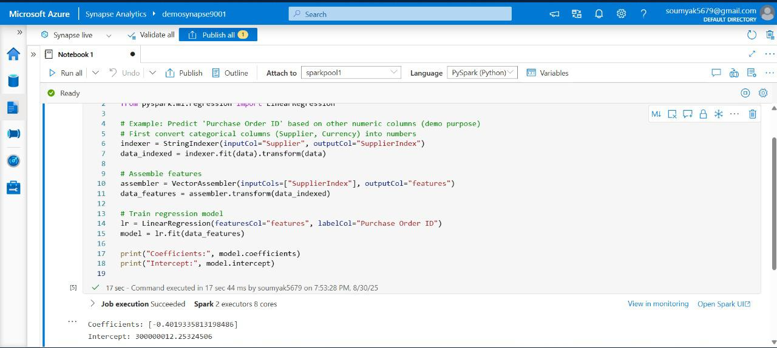

Figure: Screenshot showing ML assembler for Spark job execution

Here are some of the best practices and standards in implementing query optimization techniques in Azure Synapse tables

* Analyze query plans using Synapse Studio’s built-in tools.
* Minimize data movement across nodes by careful distribution design.
* Periodically review statistics and update as data evolves.

Implementing Data Security

Security must be woven into the fabric of every data platform. Azure Synapse provides comprehensive controls to ensure data is protected throughout its lifecycle.

Security must be an integral part of any data platform, and Azure Synapse provides robust features to ensure your data is protected at rest, in transit, and in use. When building data models that may contain sensitive information, you need to consider authentication, authorization, data encryption, and auditing requirements from the start.

Let’s outline the core security aspects in Synapse dedicated SQL pools and how to implement them:

* **Authentication**: Synapse uses Azure Active Directory (Azure AD) as the primary means of authenticating users and services. This means you grant access to Synapse resources via Azure AD identities – typically corporate user accounts or service principals. You can also enable **Managed Identity** for the Synapse workspace, which is an identity for Synapse to use when connecting to other services securely (like reading from storage without explicit credentials). In practice, a user connecting to Synapse Studio will log in with Azure AD credentials, and that identity is used to determine access.
* **Authorization (Access Control)**: Synapse supports role-based access control at two levels. At the **workspace level**, you can assign Azure RBAC roles (like Synapse Administrator, Synapse Contributor, Synapse Reader) to control who can do what in the workspace (e.g., manage the whole workspace vs just use the SQL pool). Inside the SQL pools, Synapse has its own user and role model similar to SQL Server. You can create logins/users (linked to Azure AD identities or groups) and then use **GRANT/DENY** on database objects. For example, you might create a database role DataAnalystRole that has SELECT permissions on certain schemas or views, and add users to that role. The principle of least privilege should guide you: give users access only to the data they need. If certain tables contain PII, you might restrict them and only expose a masked view.
* **Data Encryption**: All data in Synapse (dedicated SQL) is **encrypted at rest** by default (using service-managed keys, or you can bring your own key for extra control). Data in transit is encrypted via TLS. There’s not much you need to do to enable this – it’s on by default for all Azure services. Additionally, Synapse supports features like **Always Encrypted** (where certain columns’ data is encrypted such that even the database can't read it without the client’s key) – though configuring that requires setting up encryption keys and is typically done in applications. For most, encryption at rest/in-transit is seamless and on by default.
* **Network Security**: By default, a Synapse workspace is accessible over the internet with proper credentials, but you can lock it down. Using **Managed Virtual Networks** and **Private Endpoints**, you can ensure that the Synapse SQL endpoint is only accessible from within your organization’s network or from specific whitelisted IPs. If you have strict enterprise security, deploying Synapse with a private endpoint (so it's not exposed publicly) and accessing it via an Azure VPN or ExpressRoute is advisable.
* **Row-Level Security (RLS)**: Synapse (dedicated SQL) supports row-level security policies similar to SQL Server. You can create security policies with predicates that filter rows based on the executing user, to enforce that e.g., a regional manager only sees data for their region. Implementing RLS involves creating an inline table-valued function and a security policy that binds it to the table. It’s a bit complex, but effective for multi-tenant or multi-user scenarios. If needed, RLS can be part of your data model security (for instance, ensure each query on FactSales is silently filtered by region or department).
* **Dynamic Data Masking**: This is a feature where certain sensitive columns (like Emails, SSNs, phone numbers) can be masked in query results for users who are not authorized, while still stored in full in the database. For example, a phone number might appear as XXX-XXX-1234 to a junior analyst, but the data steward can see the full number. You can configure masking rules on columns in Synapse, similar to SQL DB. Keep in mind, this is more for obfuscation in query results, not a true encryption.
* **Auditing and Monitoring**: Synapse can send audit logs to Azure Monitor or Log Analytics. This includes records of who ran what queries, who accessed which data, etc. Enabling auditing lets you track lineage and detect any unauthorized attempts. Also, Azure provides **Advanced Threat Protection** for SQL which can alert on anomalous activities (like suspicious queries). These are important for compliance in industries like finance or healthcare.

Performance tuning in Azure Synapse is an ongoing process of monitoring, adjusting, and optimizing the environment to handle workloads efficiently. We’ve already discussed schema design and query optimizations, which are proactive ways to achieve good performance. Performance tuning goes hand-in-hand with those, focusing on **resource management**, **system monitoring**, and iterative improvements as data and usage patterns evolve.

Key areas for performance tuning in Synapse include:

* **Resource Classes & Concurrency**
* **Data Skew and Distribution Balance**
* **Workload Management**
* **Caching and Materialized Views**
* **ETL Process Optimization**
* **Monitoring & Diagnostics**

**Resource Classes (Workload Groups):** In Synapse dedicated SQL pools, queries run under a concept of resource classes, which determine how much CPU and memory a query can use. Essentially, a user is assigned a small, medium, large, etc. resource class which maps to a fraction of the total resources. For example, the default resource class for a user might allow, say, 4 concurrent queries each using 25% of resources, whereas a larger resource class might allow a single query to use 100% but then that user can’t run queries concurrently in parallel. Tuning this means: if you have heavy data-loading or transformation queries that are mission critical, you might assign them to a higher resource class so they run faster (at the expense of concurrency). Lighter queries (like interactive BI reports) can use smaller resource classes, trading some speed per query for the ability to run many at once.

For example, you might do:

|  |
| --- |
| 1 -- Assign a specific login/user to a larger resource class  2 |

This grants **AnalystUser** more resources per query . Use this judiciously: giving everyone high resources will reduce concurrency and could exhaust memory. The goal is to balance it based on use case: ETL jobs that run off-hours might be okay to be large, while daytime reports are small but many.

**Data Skew:** We touched on this, but it’s worth monitoring. If one distribution has disproportionately more data (for instance, maybe a hash distribution on ProductID ended up with 30% of the data on one distribution because some product IDs were extremely common), that one node becomes a bottleneck (the “hot node”). Synapse’s monitoring can show if one **DFE (Data Flow Engine)** node is doing much more work. There are system views like sys.pdw_nodes_tables that can show row counts per distribution for a table. If you find skew, the fix might be to choose a different distribution key, or if that’s not possible, perhaps break the data differently (maybe use a composite key or add a salt to the key to spread it). Ideally, each distribution for a large table should have roughly equal rows .

**Workload Management & Query Prioritization:** Synapse allows classifying queries into workload groups beyond resource classes, to separate, say, ETL pipelines from ad-hoc queries. For very large systems, you might configure these so that heavy loads don’t starve quick BI queries or vice versa. This is advanced, but something to consider if concurrency gets high.

**Caching:** Synapse has an **result set cache** feature. Ensure it’s enabled if appropriate (it’s on by default for dedicated pools). This can dramatically speed up repeated queries. Additionally, **Materialized Views** we mentioned can be seen as a caching mechanism at the data level for aggregated results . Also, the **result cache** will skip actual execution if the same query (exact text) was run recently and data hasn’t changed, returning cached results in milliseconds.

**ETL Optimization:** Performance isn’t just about query speed; it’s also about how quickly you can load and refresh data. For tuning the **ETL (Extract-Transform-Load)** in Synapse:

* Prefer set-based operations (COPY INTO or bulk insert) over row-by-row. Loading 100 million rows in one batch is much faster than 100k batches of 1000 rows each .
* If using Spark in Synapse for transformation, size your Spark clusters appropriately and cache datasets when beneficial.
* Use polybase (external tables or COPY) for large loads from data lake, as it’s optimized.
* Schedule **updates of stats** after big loads, and possibly **rebuild indexes** if needed (for instance, if you do large deletions, you might reclaim space by rebuilding a columnstore index to purge deleted fragment data).

**Monitoring & Tools:** Synapse provides a **Monitor hub** in the workspace where you can see overall DWU usage, query durations, data skew, etc. There are also DMVs (dynamic management views) to get details. Key things to monitor:

* Query duration and resource usage: Identify the top N longest or most expensive queries.
* Queues: If queries are often waiting (because the warehouse is at max concurrency), maybe scale up the DWUs or use resource classes to alleviate.
* CPU and IO distribution: Are all nodes evenly utilized or is one frequently maxed out?
* Data cache hit rates: On repeated queries, if no result cache, are reads coming from disk or memory?
* Step details: For each query, look at the steps (like ShuffleMove operation taking a lot of time indicates data movement overhead).

Example: Granting Table Access

*-- Grant SELECT on a table to a data analyst*

*GRANT SELECT ON dbo.FactSales TO DataAnalystRole;*

Some of the best practices in implementing Data security in Azure Synapse based solution are:

* Use managed identities for data movement and transformation pipelines.
* Leverage dynamic data masking for sensitive columns.
* Regularly review access logs and audit trails.

Performance Tuning

Performance tuning in Synapse requires a holistic approach, considering hardware resources, data distribution, indexing, and query design. Synapse Studio provides a way to view the query plan and steps for distributed queries. It breaks down how data is moved or joined across nodes. A good practice is to analyze the plans of your most important queries (say nightly reports or dashboards) and see if there are any heavy ShuffleMove operations or skew (one node taking much longer). This can inform if you need to redesign distribution keys or add an index.

Key Areas:

* **Resource Classes**: Allocate compute resources by workload using resource classes.
* **Data Skew**: Monitor and address data distribution imbalances.
* **Concurrency**: Tune parallelism settings for query workloads.
* **Cache Management**: Use result set caching and materialized views.

Example: Adjusting Resource Classes

*-- Assign user to a higher resource class for large queries*

*ALTER USER [username] WITH RESOURCE_CLASS = 'xlrc';*

In this Monitoring Example, Utilize Synapse Studio’s monitoring dashboard to visualize query execution times, resource utilization, and bottlenecks.

Some of the best practices in monitoring and performance tuning are

* Regularly analyze query performance metrics.
* Revisit data distribution strategies as data volumes grow.
* Optimize ETL processes for incremental loads.

## Recipe: Optimizing Performance

Azure Synapse Analytics has emerged as a cornerstone for modern data warehousing and analytics solutions, enabling organisations to process vast amounts of data efficiently. Performance optimisation within Synapse is crucial to ensure timely insights, cost-effective operation, and a seamless user experience.

# Azure Services Required

To build a robust performance optimisation solution with Azure Synapse, several Azure services play pivotal roles:

* **Azure Synapse Analytics**: The primary data platform, providing integrated analytics capabilities for big data and data warehousing.
* **Azure Data Lake Storage Gen2**: Offers scalable, secure storage for raw and processed data, enabling efficient data ingestion and staging.
* **Azure Data Factory**: Facilitates data movement and transformation, orchestrating data pipelines between sources and Synapse.
* **Azure Monitor**: Delivers insights into resource utilisation and query performance, essential for ongoing optimisation.
* **Azure Active Directory**: Ensures secure access control and authentication across Synapse and supporting services.

Together, these services establish a foundation for building, managing, and optimising data workloads in Synapse.

### Step-by-Step Recipe Development

Building an optimisation recipe in Azure Synapse involves the following structured steps:

1. **Assess Workload and Data Patterns**: Begin by analysing query logs, data growth trends, and reporting requirements to identify bottlenecks.
2. **Design Table Distribution**: Select distribution methods for each table based on size and join patterns. Use hash distribution for large fact tables, replicated for small dimension tables, and round-robin for staging areas.
3. **Implement Indexing**: Apply clustered columnstore indexes to analytical tables. Add non-clustered indexes only where filtering or joining is critical, avoiding unnecessary overhead.
4. **Configure Partitioning**: Partition large tables on columns that align with frequent query filters. Set up partition boundaries to balance performance and maintenance.
5. **Enable Result Caching**: Activate result caching for eligible queries, particularly those powering dashboards or recurring reports.
6. **Create Materialised Views**: Identify and materialise frequently requested, computationally expensive queries. Automate refresh schedules according to data update frequency.
7. **Monitor and Refine**: Use Azure Monitor and Synapse workspace insights to track query performance, resource utilisation, and user experience. Continuously fine-tune distribution, indexing, partitioning, and caching settings as workloads evolve.

This methodical approach ensures that each layer of performance optimisation is addressed, resulting in a high-performing, scalable Synapse environment.

Optimising performance in Azure Synapse is a multifaceted endeavour, requiring thoughtful integration of table distribution, indexing, partitioning, result caching, and materialised views. By leveraging the right Azure services and following a step-by-step recipe, cloud architects and data engineers can unlock significant improvements in query speed, resource efficiency, and user satisfaction. Ongoing monitoring and iterative refinement are essential for sustaining performance as data landscapes and business requirements evolve. With these best practices, organisations can realise the full potential of Azure Synapse Analytics for their data-driven initiatives.

Now, lets look at these steps with screenshots

* Review table distribution, indexing, and partitioning settings.
* Leverage result caching and materialized views for frequently requested reports.

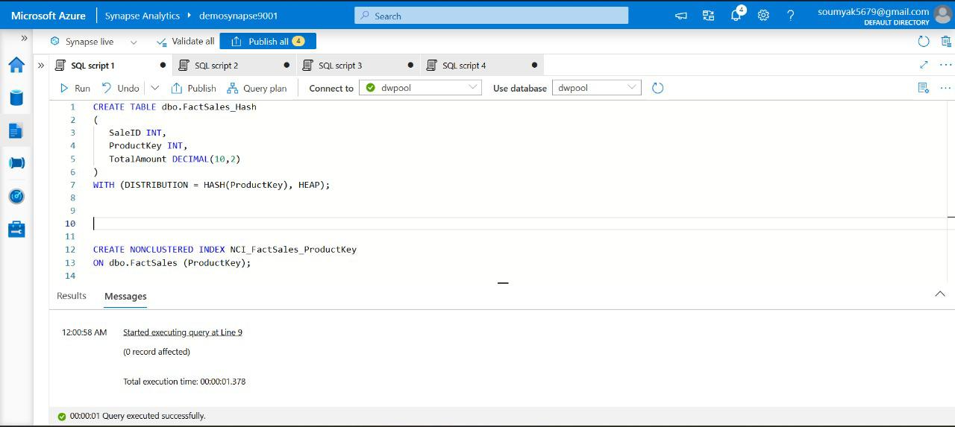

Figure: Screenshot showing query execution time

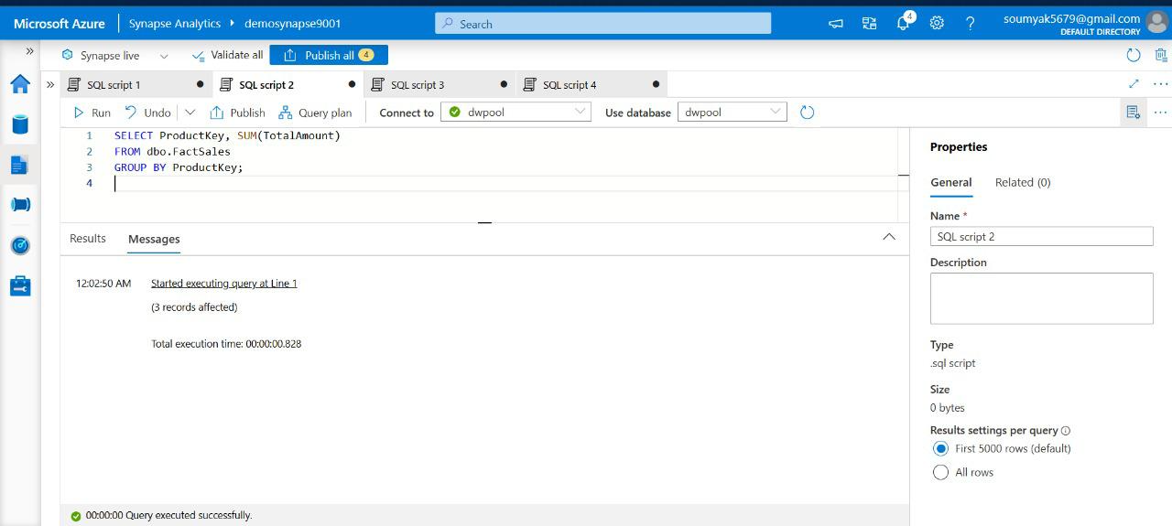

Figure: Screenshot showing result setting to optimize query execution

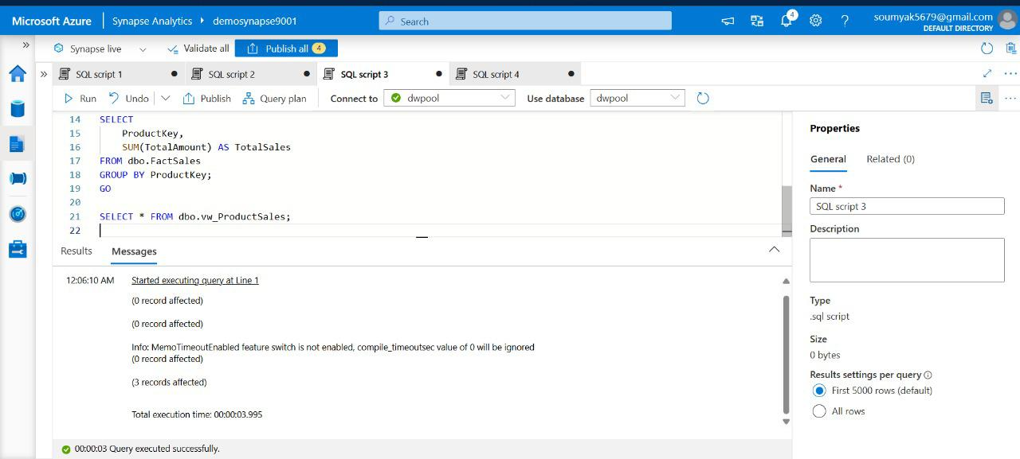

Figure: Screenshot showing result setting to tune query

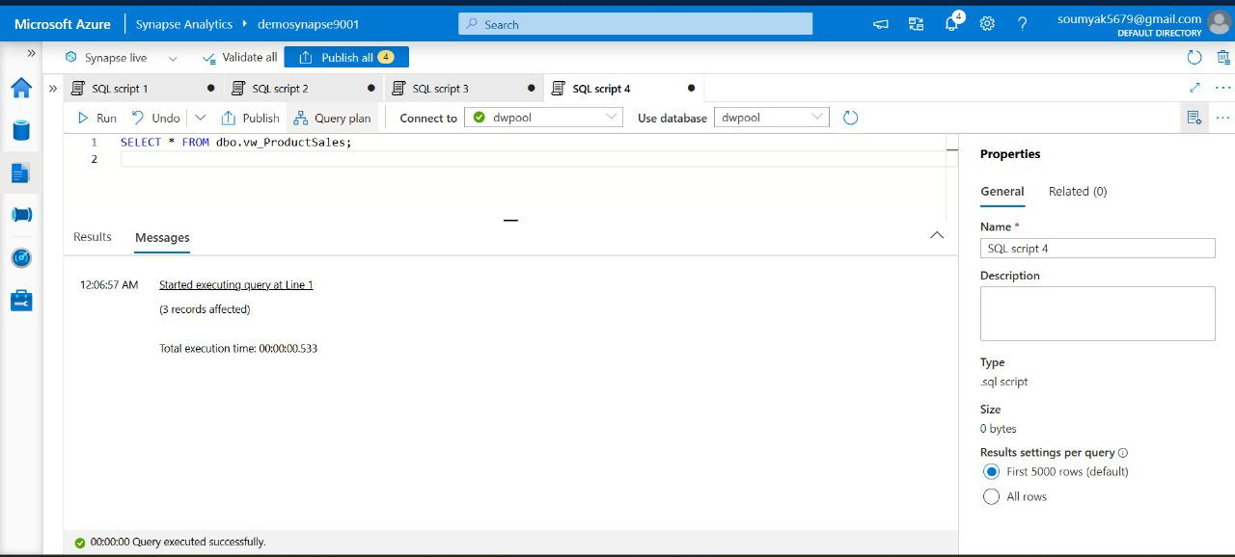

Figure: Screenshot showing optimized query result

Best Practices for Data Modeling

Effective data modeling reduces complexity, increases performance, and ensures scalability. When working in Synapse, best practices include:

* Always separate staging, core, and analytics layers—each with its own schema.
* Adopt naming conventions that are descriptive and consistent.
* Document data lineage and transform logic.
* Validate model assumptions through iterative prototyping.
* Engage stakeholders in model reviews for alignment and usability.
* Plan for change; ensure models are extensible and adaptable.

Example: Data Vault Modeling

Data Vault combines the benefits of 3NF and star schema for agility and auditability. In Synapse, implement hubs, links, and satellites to manage complex data integration scenarios.

*-- Example: Creating a Hub Table*

*CREATE TABLE dv.HubCustomer*

*(*

*CustomerKey INT PRIMARY KEY,*

*CustomerHash UNIQUEIDENTIFIER,*

*LoadDate DATETIME2*

*);*

## Recipe: Monitoring and Troubleshooting

Azure Synapse Analytics stands as a powerful analytics service that brings together big data and data warehousing. Its ability to manage, integrate, and analyse vast amounts of data makes it invaluable for modern enterprises. However, to ensure peak performance and reliability, it is crucial to monitor operations and troubleshoot issues proactively.

## **Understanding Synapse Studio**

Synapse Studio is the primary interface for managing and interacting with Azure Synapse Analytics. Designed as a unified workspace, it enables users to develop, monitor, and manage data integration pipelines, SQL and Spark pools, and data exploration tasks—all within a single, web-based environment. Its intuitive dashboards and built-in monitoring capabilities make it an essential tool for IT professionals and data engineers aiming to maintain the health and efficiency of their analytical workloads.

## **Azure Services Required**

To build a robust monitoring and troubleshooting recipe for Azure Synapse, several Azure services come into play. The following components are integral to the solution:

* **Azure Synapse Analytics**: The core platform providing integrated analytics capabilities, including data warehousing and big data processing.
* **Azure Monitor**: This service collects, analyses, and acts on telemetry data from Synapse Analytics, offering visibility into application health and usage.
* **Azure Log Analytics**: A feature within Azure Monitor, Log Analytics enables querying and analysing logs generated by Synapse resources for deeper insights.
* **Azure Data Lake Storage**: Often used for storing diagnostic logs and monitoring outputs for further analysis.
* **Azure Active Directory**: Facilitates secure access and role-based permissions within Synapse Studio and related services.

## **Monitoring in Synapse Studio**

Effective monitoring within Synapse Studio involves observing the status, performance, and health of various components, such as pipelines, SQL pools, and Spark pools. The following steps outline how monitoring is performed using Synapse Studio:

1. **Access the Monitoring Hub**: Upon logging into Synapse Studio, navigate to the Monitor hub. This centralises all monitoring activities and provides an overview of recent operations.
2. **Monitor Pipelines**: In the Integrate section, select the desired pipeline and review its activity runs. Synapse Studio displays execution status, duration, and any errors encountered. You can drill down into activity details for granular insights.
3. **SQL Pools Monitoring**: Under the SQL pools tab in the Monitor hub, observe resource utilisation metrics such as CPU usage, memory consumption, and query activity. This helps in identifying bottlenecks or abnormal behaviour.
4. **Spark Pools Monitoring**: Similarly, select the Spark pools area to track active and historical Spark jobs. Metrics like job duration, executor health, and resource allocation are readily available for review.
5. **Set Up Alerts**: Integrate with Azure Monitor to configure alerts based on custom thresholds or specific events. This ensures timely notifications when anomalies or failures occur.

## **Troubleshooting with Synapse Studio**

When issues arise, Synapse Studio offers several tools and techniques to identify and resolve problems:

* **Pipeline Debugging**: Use the Debug feature to run pipelines in test mode, allowing step-by-step examination of dataflows and activities without impacting production data.
* **Error Details and Logs**: For failed pipeline runs, Synapse Studio provides detailed error messages and stack traces. These can be further investigated using logs stored in Azure Data Lake Storage or accessed through Log Analytics.
* **Query Performance Insights**: For SQL pools, leverage built-in query performance tools to identify slow-running queries and resource-intensive operations. Recommendations for query optimisation are often available.
* **Spark Diagnostics**: Spark job failures can be analysed using diagnostic logs, executor details, and job execution timelines, all accessible within Synapse Studio.
* **Integration with Azure Monitor**: Advanced troubleshooting is possible by querying logs and telemetry in Azure Monitor and Log Analytics, enabling root cause analysis and long-term trend identification.

## **Developing the Recipe**

Building a comprehensive monitoring and troubleshooting recipe involves a series of configuration and integration steps:

1. **Enable Diagnostic Settings**: In the Azure portal, configure diagnostic settings for Synapse Analytics to send logs and metrics to Log Analytics, Azure Monitor, and Data Lake Storage. This ensures all relevant data is captured for monitoring and troubleshooting.
2. **Configure Access and Permissions**: Use Azure Active Directory to assign appropriate roles to users, ensuring both security and operational efficiency.
3. **Customise Monitoring Dashboards**: Within Synapse Studio, tailor dashboards to display key metrics relevant to your workloads, such as pipeline success rates, query performance, and resource utilisation.
4. **Set Up Automated Alerts**: Define alert rules in Azure Monitor for critical conditions—like failed pipeline runs or resource spikes—so that responsible teams are immediately notified.
5. **Integrate with Log Analytics**: Build custom queries to analyse logs for recurring issues, usage patterns, or security events. These insights help in proactive troubleshooting and capacity planning.
6. **Establish Best Practices**: Regularly review monitoring configurations, update alert thresholds as needed, and document troubleshooting procedures to ensure consistent and efficient incident response.

In summary, monitoring and troubleshooting Azure Synapse using Synapse Studio is a structured process that leverages a suite of Azure services for comprehensive oversight and rapid issue resolution. By following the outlined recipe—encompassing configuration, integration, and best practices—IT professionals and data engineers can enhance system reliability, optimise performance, and ensure data operations run smoothly. Ultimately, this proactive approach not only minimises downtime but also empowers teams to deliver robust analytics solutions with confidence.

Now lets see the recipe steps and screenshots to develop the approach further as below:

* Use Synapse Studio’s monitoring hub to track pipeline runs, query performance, and resource utilization.
* Set up alerts for failed jobs or resource bottlenecks.

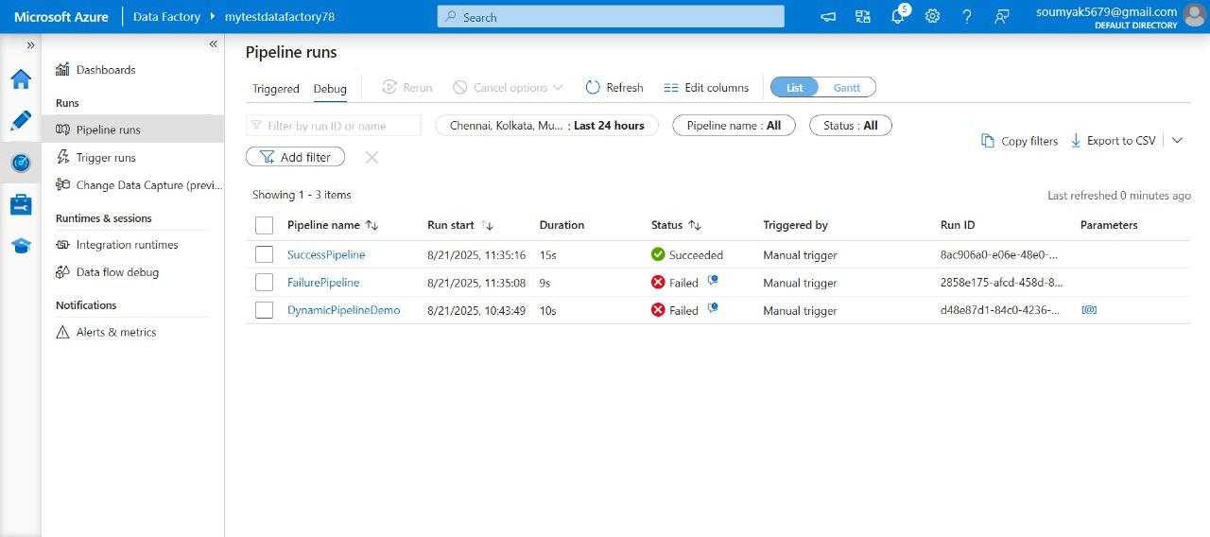

Figure: Screenshot showing Pipeline runs for monitoring status

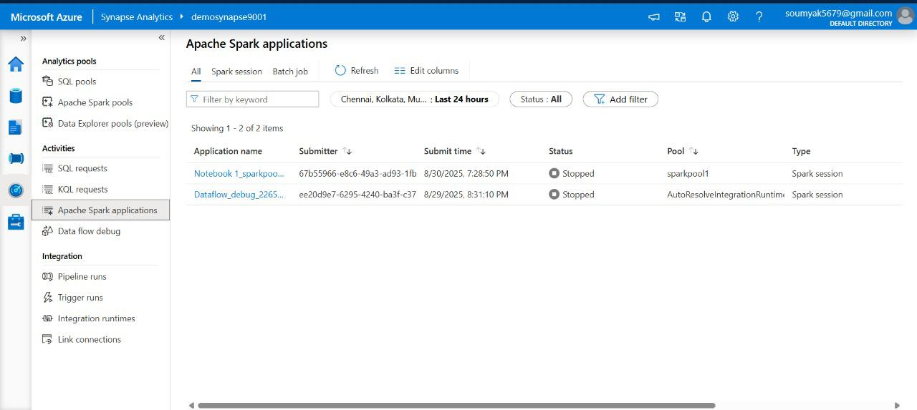

Figure: Screenshot showing Apache spark application monitoring in Synapse analytics

## Recipe: Automating Workflows

* Design Synapse Pipelines for scheduled ETL jobs, data refreshes, and notifications.
* Incorporate triggers to automate execution based on time or events.

Example:

-- Create a trigger for daily data load

CREATE TRIGGER DailyLoad

ON SCHEDULE EVERY 24 HOURS

AS EXEC dbo.LoadSalesData;

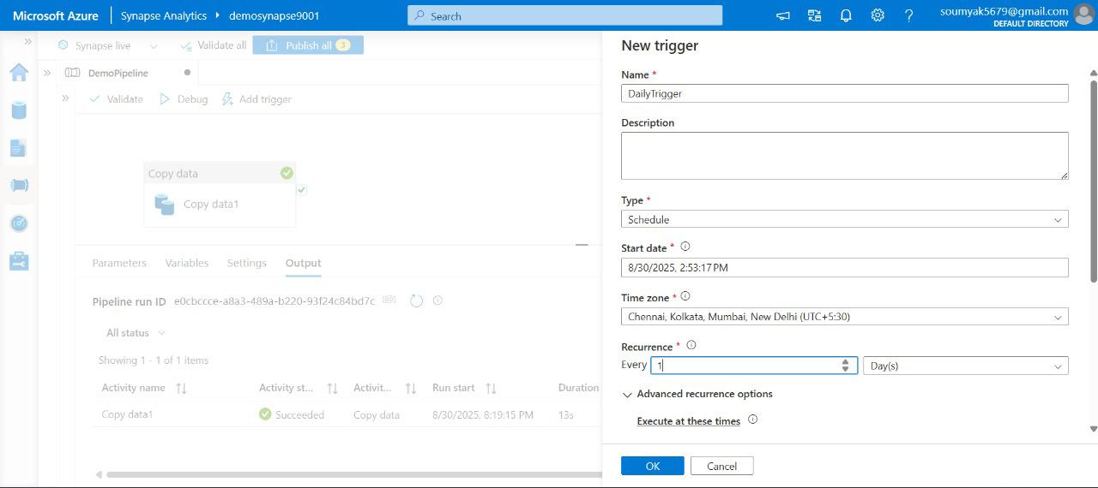

Figure: Screenshot for creating triggers for automation job in Synapse analytics

## Recipe: Ensuring Data Security and Compliance

* Apply RBAC and managed identities for access management.
* Implement data classification, masking, and encryption for sensitive information.
* Leverage Azure Policy and compliance features for regulatory adherence.

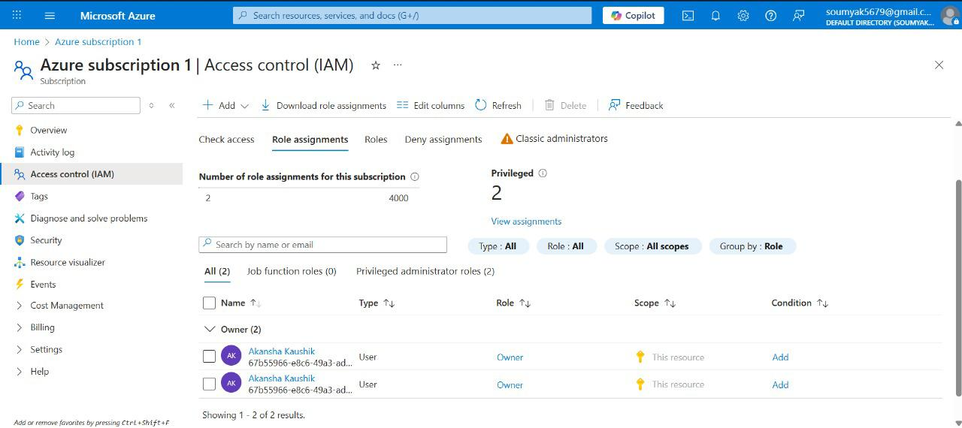

Figure: Screenshot showing IAM control for Synapse

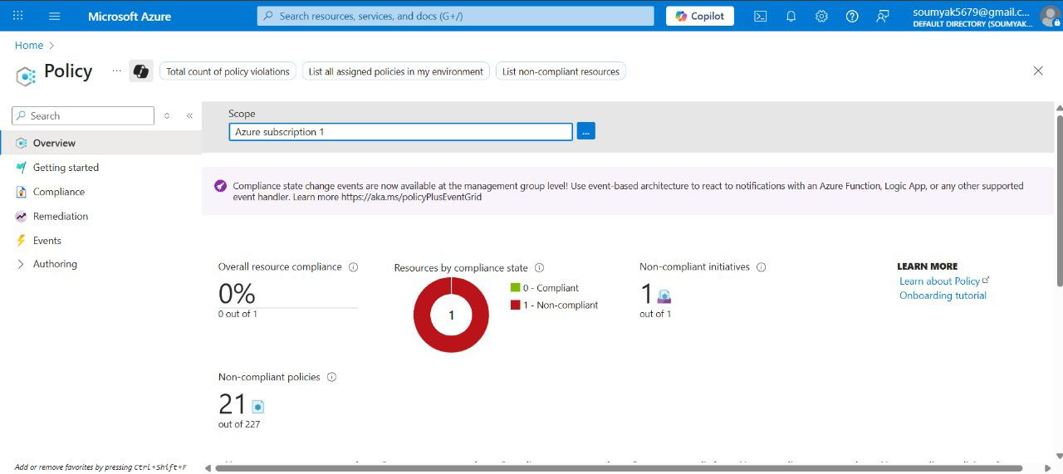

Figure: Screenshot showing Policy definition for Synapse security settings

Below is a table summarizing some of these best practices for quick reference:

|  |  |
| --- | --- |
| Best Practice | Guidance |
| Use a Star Schema Design | Model data in facts and dimensions for clarity and performance. Avoid over-normalizing (too many joins) and over-denormalizing (one big table)2. A star schema or modest snowflake ensures simpler queries and aligns with Synapse’s MPP strengths. |
| Smart Distribution of Tables | Choose distribution keys that align large tables with their join partners. Hash-distribute big tables on a key used in joins, and replicate small tables to all nodes22. This minimizes expensive data shuffles at query time. |
| Optimize Data Types & Compression | Use the smallest data type that fits your data (e.g., INT vs BIGINT) and prefer VARCHAR with appropriate length over NVARCHAR when possible2. Leverage clustered columnstore indexes on large tables for high compression & fast scanning2. |
| Minimize Data Movement | Design to avoid moving data across nodes during queries. For example, duplicate or pre-aggregate data if it prevents repeated heavy joins2. It’s better to store a calculated field than to recompute it on billions of rows each time, if it’s frequently needed. |
| Batch and Bulk Load Data | Load and transform data in large batches rather than one row at a time. Use PolyBase or COPY for bulk ingestion. Synapse performs best with set-based operations – e.g., insert 1M rows in one transaction instead of 1 row in 1M transactions2. |
| Layer and Segregate Schema | Separate staging vs. curated data. Use schemas (or separate databases) for raw stage tables, core warehouse tables, and presentation views1. This organization improves manageability and security (you can grant access at schema level). |
| Document and Review | Maintain a data dictionary for all tables and columns, noting their purpose and any transformations2. Regularly review the model with stakeholders and perform data quality checks to ensure the model remains accurate and useful2. |
| Plan for Evolution | Design with change in mind. Use surrogate keys and abstracted views to insulate against source system changes. When requirements change or new data sources arrive, iterate the model rather than forcing everything into an old design2. Keep SQL scripts in version control to track changes over time. |
| Leverage Synapse Features | Keep up with Azure Synapse updates. New features like materialized views, result set caching, or improved indexing can significantly boost performance2. Integrate Azure Purview for governance and use performance recommendations (e.g., through Azure Advisor) to continuously optimize. |
| Embed Security at Every Layer | Apply RBAC, row-level security, and data masking as needed before users access the data. For example, use views to expose only necessary columns to certain roles. Ensure sensitive data is encrypted and that you have auditing enabled for compliance. |

By adhering to these best practices, your **Azure Synapse data model** will be well-positioned to deliver robust performance and value. The combination of sound design (star schema, proper distribution), proactive optimizations (statistics, indexes, batching), and rigorous governance (security, documentation, monitoring) creates a data foundation that can scale with your organization’s needs. Building data models is an iterative journey, but with the right principles in place, Synapse provides all the tools to make that journey successful – enabling your team to turn raw data into actionable insights efficiently and securely.